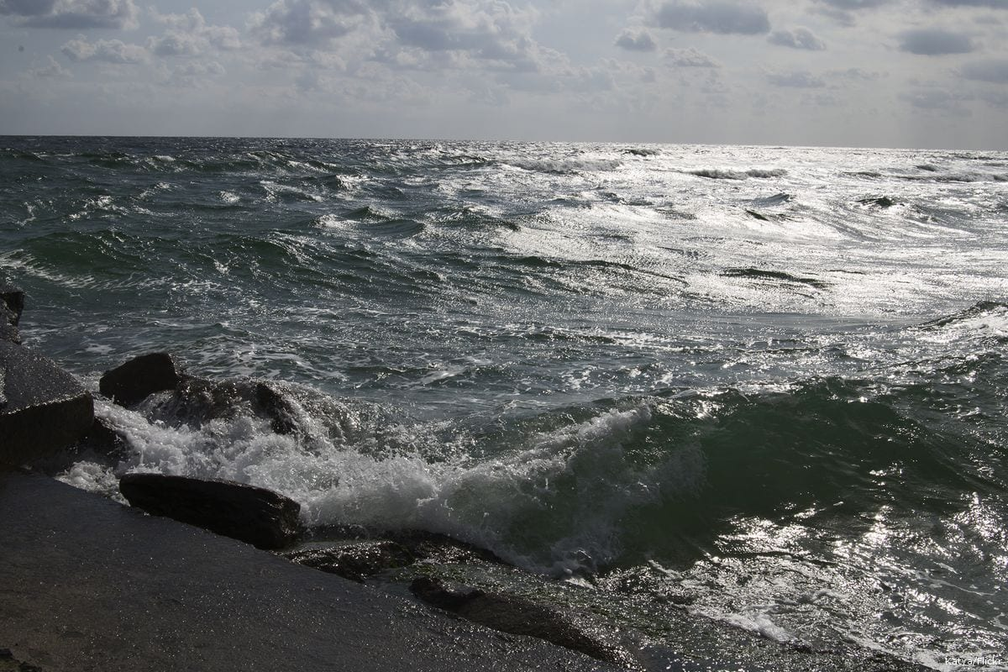

[This Photo](https://www.middleeastmonitor.com/20200820-turkey-discovers-natural-energy-resources-in-the-black-sea/) by Unknown Author is licensed under [CC BY-SA-NC](https://creativecommons.org/licenses/by-nc-sa/3.0/)